SP6CA1 Rev 2.0

J1

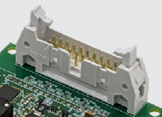

Power supply

J1 Pin1,3,5,7 🡪 +15V

Vdc in= 14~16V (I=366mA SiC dependent assume a MOSFET with Ciss =36.24 pF and Qg=2584nC @50KHz )

J1 Pin 2,4,6,8,10,14 🡪 GND DIGITAL

* Input PWN signal should not be activated until 20ms after power is applied to allow on board DCDC converter to stabilize.

PWN signals for Gate Drivers

Set single ended 15V operation:

Install RS1~RS6

Remove RD1~RD6

J1 Pin 11 🡪trigger input for High side

J1 Pin 15 🡪trigger input for Low side

Vin_Low = 4Vmax

Vin_High= 10Vmin

Input Impedance =2000R

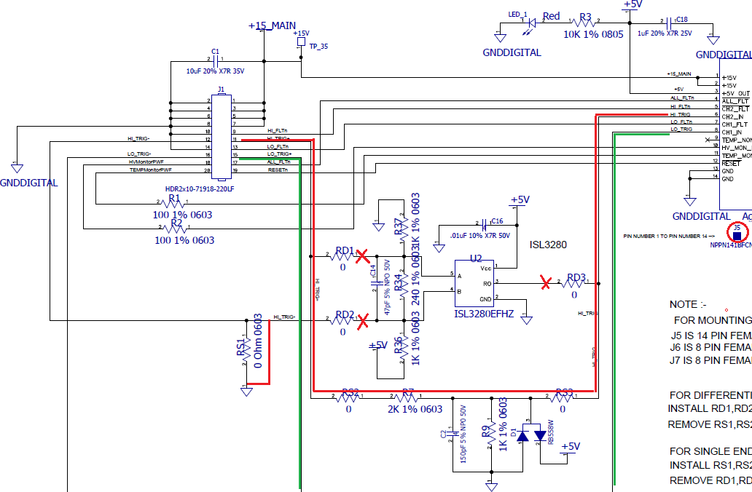

Set 5V operation: not recommended

Vin_Low = 1.25Vmax

Vin_High= 3.5Vmin

Input Impedance =100R

ISL3280EFHZ U2,U3 for differential input and output triggers core.

Vin =2Vmin (Vin+ to Vin-)

Monitor

Pin 16 🡨 open

Pin 18 🡨output / High Voltage monitor PWF

Pin 20 🡨output / Temp monitor PWF

Fault output open collect 2KR Pull Up required

Pin 9 🡨 J5.Pin5 high side

Pin 13🡨 J5.Pin7 Low side

Pin 17🡨 J5.Pin4 All Fault

Reset

Pin 19 🡪 J5. pin12

Master to Slave driver connection option

J3

J4

NTC

VBUS

J6 High side

Pin1 🡨 DSAT signal

Pin2 🡪 provide +VHI

Pin3 🡪GND-HI

Pin4,5 To turn on Q1 2SC5569 turn on G1

To turn oon Q2 2SA2016 turn off G1

Pin6 🡪 provide -VHI

Pin7 NC

Pin3 🡪GND-HI

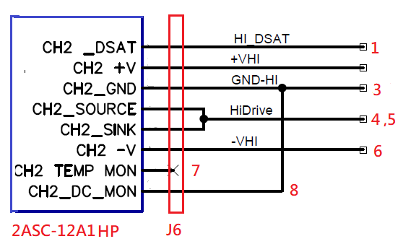

J7 Low side

Pin1 🡨 DSAT signal

Pin2 🡪 provide -VLo

Pin3 🡪GND-Lo

Pin4,5 To turn on Q1 2SC5569 turn on G2

To turn oon Q2 2SA2016 turn off G2

Pin6 🡪 provide +Lo

Pin7 🡨 DCMonitor

Pin8 🡪TEMP monitor noiso

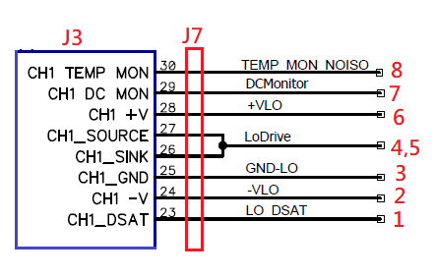

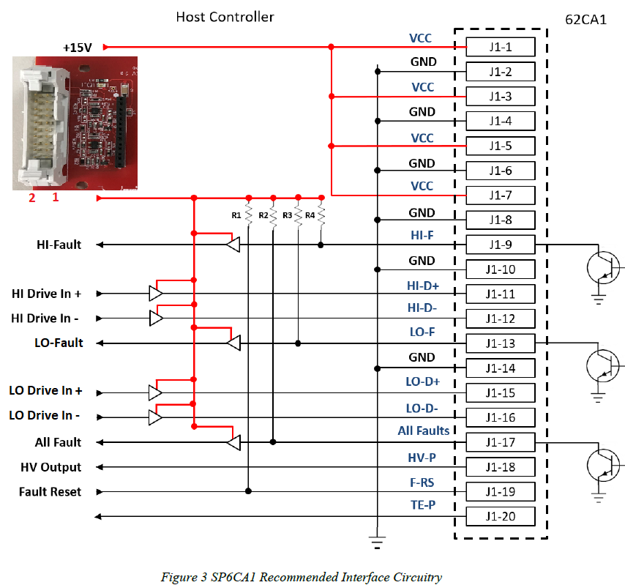

Host Specs:

Output:

DIP switch to change output frequency

50KHz /100K PWM signals for Hi Drive In+

50KHz /100K PWM signals for LO Drive In+

dead time between Hi Drive and In+ and LO Drive In+: 1uS /0.5uS

Duty 45% / 25%

I/Os open collect?

Tact switch

Hi side DSET test output : logic Lo to Hi after Hi Drive In+ PWM signal

Lo side DSET test output : logic Lo to Hi after LO Drive In+

Reset :

**Input:**

HI-Fault: to light a LED1 (blinking 0.5Hz) open collect

LO-Fault: to light a LED2 (blinking 0.5Hz) open collect

All-Fault: LED1 and LED2 blinking open collect

Display:

HV_MON_PWM (J1-18): **0V-5V** 31.5KHz /10% to 90% **Temperature (25℃~175℃) /**

TEMP_MON_PWM (J1-20) : **0V-5V**  31.5KHz /10% to 90% **DC Link Voltage output (0~1000V)**

2ASC-12A1HP Core configuration / PWM Scaling mode is not selected (Disabled)

PWM signals can be either fixed low **(0% duty cycle)** or high **(100% duty cycle)** outputs if the Temperature and DC Link Voltage inputs are at their minimum or maximum input levels, respectively.